**Project Design Phase-II**

**Solution Requirements (Functional & Non-functional)**

|  |  |
| --- | --- |
| Date | 31 January 2025 |
| Team ID |  |
| Project Name | Enchanted Wings : |
| Maximum Marks | 4 Marks |

**Functional Requirements:**

Following are the functional requirements of the proposed solution.

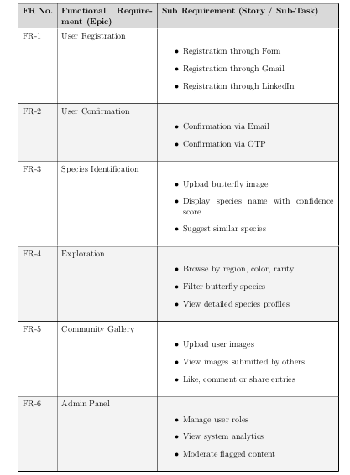

|  |
| --- |
| **Non-Functional Requirement :** |

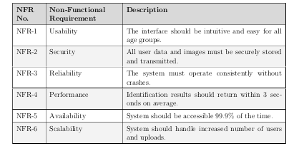Following are the non-functional requirements of the proposed solution.